- Christian Aid Week 2026 — Growing hope
All-age worship service guide

Introduction
This all-age worship is part of the celebrations for Christian Aid Week. It aims to enable inter-generational learning and sharing. Contributions from everyone are encouraged and welcomed. There are activities that can engage people of any age. At the heart of this service is an exploration of these big questions:
- What gives us hope?
- Where does our hope come from?
- How can we learn from one another to live and sustain hopeful lives?
- What can we learn from the story of Christian Aid’s partner Beacon of Hope, and how they are creatively responding to hunger in their community?
Some songs have been suggested but feel free to use any others you prefer.
All the following ideas can be adapted for use in Sunday school/Messy church settings as well as a main all-age service.

You will need:
- The accompanying PowerPoint™ (the relevant slides are indicated throughout this service outline).
- Timelapse video of a mustard seed growing is embedded in the slideshow, but you may wish to set it up separately ready to show, with the advert at the start already skipped.
- Scrap paper.
- Pens and pencils.
- Packet/s of mustard seeds.
- Baby vegetable plants (if you have read these instructions in advance you may have time to grow some radishes/lettuce/rocket/spinach from seed).
- Egg boxes cut into individual plant pots – one for each person.
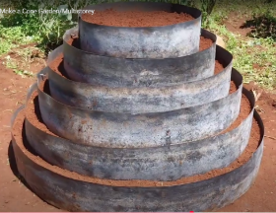
- 4 plant pots of different sizes – try to find a large one for the bottom, leaving enough room to add the plants. See photo of a ‘cone garden’.
- Large plastic sheet to go under the plant pots.
- Enough compost (peat-free) to fill the cone garden and egg box plant pots.
- An old tablespoon to scoop the compost.
- Collection plate/bucket/envelopes for Christian Aid.

To order Christian Aid Week resources, please visit caweek.org/resources or scan the QR code.

Gathering
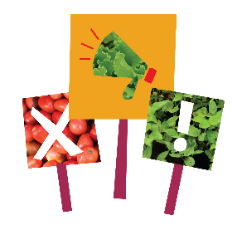
Song to begin the service: We are marching in the light of God.
Adapter: Anders Nyberg (b. 1955) Tune: SIYAHAMBA
Arranger: Anders Nyberg.
Slide 1: Explain that this service is part of the celebration and support of Christian Aid Week – a time each year to think about global justice and the role that we can play together to ensure that we can tackle the root causes of poverty.

Slide 2: Ask if anyone can tell you who/what Christian Aid is?
Christian Aid is an international charity rooted in Christian faith and hope,
determined to tackle poverty and respond to emergencies.

Slide 3: Christian Aid works in three main ways:
- Supporting people to live the life they want, free from poverty and injustice.
- Responding to emergencies such as earthquakes, floods and conflict, and working with communities to prepare for disasters.
- Calling on politicians and leaders to make a fairer world for everyone.

Slide 4: This Christian Aid Week we are focusing on how to tackle hunger and food poverty in Nairobi. Does anyone know where Nairobi is?

Nairobi is the capital city of Kenya in Africa and is home to over 5 million people.

Slide 5: Starter activity – two-minute doodle: give everyone a piece of paper and a pen/pencil. Invite them to do a quick doodle of whatever comes to mind when they think of a city.


After two minutes, ask one or two people to describe what they have drawn. People may well draw big buildings, busy roads, lots of shops, crowds of people. Has anyone drawn parks or trees?
Discuss how when we think of cities, we usually imagine the hustle and bustle, skyscrapers, buses, busy roads, shops and museums. We are less likely to picture green spaces, especially not areas where we can grow food.

This year for Christian Aid Week, we are exploring how to tackle hunger and poverty through urban farming – growing food in cities and built-up spaces.

Slide 6: At this point in the service, it is important to explain how food poverty affects many families across the UK. Some themes in this service are likely to reflect the experiences and worries of people here. Many rely on foodbanks and face difficult decisions and extraordinary challenges daily.

Draw attention to the work of a local foodbank or describe the work of an organisation such as the Trussell Trust.

Christian Aid is working with partners and communities in Kenya who are finding clever answers to the problem of getting enough food for families to eat. The stories we will be exploring today are filled with hope and good ideas to solve some very complicated problems. We hope these ideas may inspire us to help tackle poverty and hardship in our own communities too.

This could be a good opportunity to sing Let Justice Roll..
Credit: Suzanne Butler, Stephen Fischbacher, Margaret McLarty
Engaging
Slide 7: Show the picture of Nairobi. Ask people to discuss in groups:
- What can you see / what do you notice?
- In what ways is this similar to, or different from, your doodles?
- What would it be like to live there?

Point out that alongside Nairobi’s big skyscrapers and luxury safaris, Kenya’s capital holds areas of poverty and hardship. Here, most people are living on less than a dollar a day, and many families regularly go without meals.

Slide 8: Thousands of people have had to move to the city in search of work. That is because in many parts of Kenya, poverty and the climate crisis are making it very hard for people to grow crops to feed their families, and to pay for education and health care.


Many of these people that move to Nairobi end up living in places called informal settlements. These are very overcrowded areas where there is often no running water or electricity. Work can be hard to find, and pay is very low. This puts families in incredibly difficult situations, with little money or food. No-one should have to live like this.

Slide 9: In Dagoretti, one of these settlements, Christian Aid is supporting a partner organisation called Beacon of Hope. They are growing hope for the future, using something very small indeed. Let’s find out more.

Slide 10: Read Luke 13:18-19.

Slide 11: Watch the Timelapse video of a mustard seed growing (with the sound turned off so it is watched in silence).

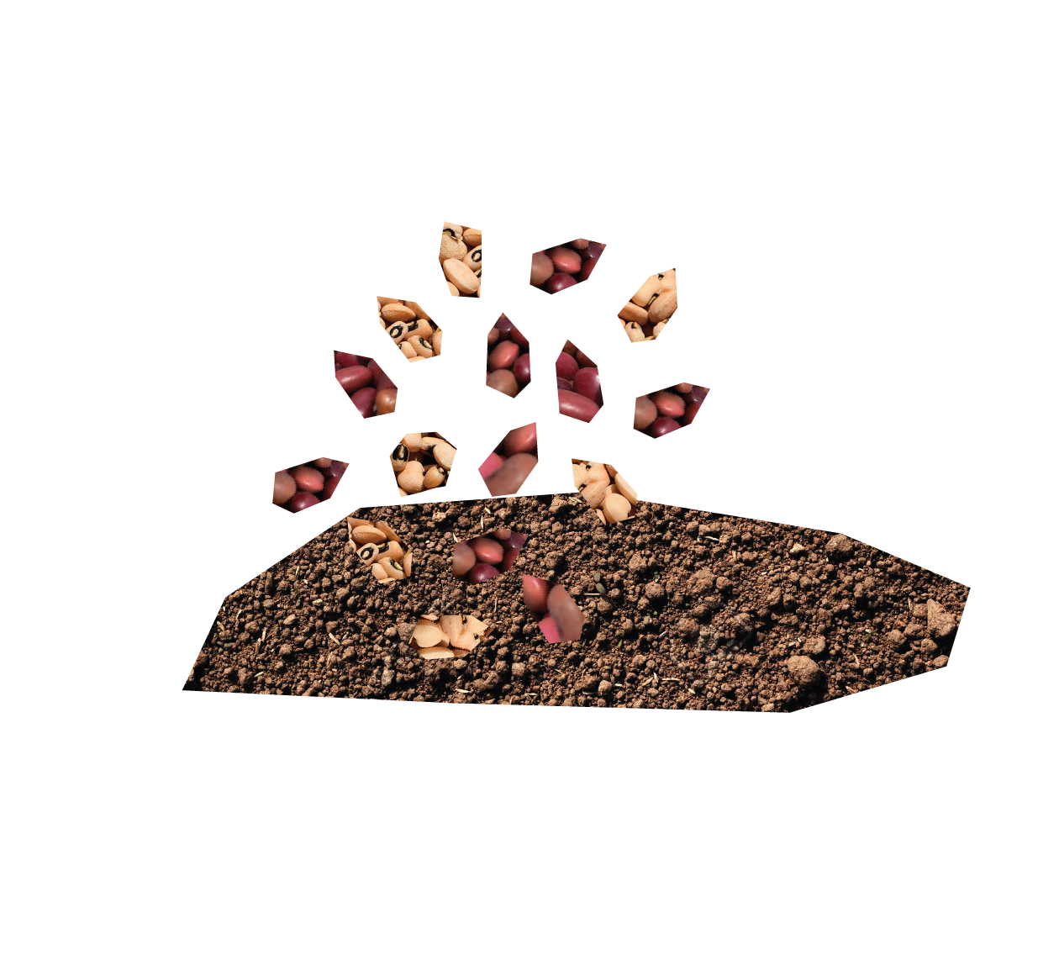
Slide 12: Explain that when Jesus wants to talk about the kingdom of God, he uses the idea of planting a small mustard seed. He describes how it grows into a tree that becomes a home for many birds. The tiny seed turns into something mighty that can sustain all manner of life. Faith doesn’t simply mean something you only believe in your thoughts. Faith is belief worked out into our actions.

We are going to look at and learn from a story of faith in Nairobi – a story about Beacon of Hope.

Slide 13: Show a photo of a ‘cone garden’ in Dagoretti settlement. Explain that together you are going to build your own, using a pyramid of plant pots.

Invite people of all ages to come and help build your cone garden, as you tell the story of Beacon of Hope. Have an adult primed and ready to help oversee the making of the garden. Help volunteers to fill each of the four plant pots about two thirds full and then stand them on top of each other to create a pyramid. Then ask them to fill the pots and add the young vegetable plants. Encourage those who are making the garden to listen and reflect as they do so.

Slide 14: Cone gardens are a key element of how Beacon of Hope trains and supports the local community in Dagoretti to farm in tiny city spaces. Fridah Moraa is a mum and grandma who has learned to grow food for her family using this space-saving method.

Fridah is raising her 13-year-old twin sons Eliud and Abiud, her daughter, and four-year-old grandson, Quillan. The family live in a small metal shelter. They have to share a toilet with other families and have no indoor running water.

In these conditions, keeping her family healthy and safe from disease is a constant battle for Fridah, and one she must face alone. That’s because, in February 2025, a tragic accident took the life of her husband.

Slide 15: Like many families in the overcrowded streets of Dagoretti, day-to-day life for Fridah is difficult. She worries every morning about how to get enough food for the children. She earns money by selling vegetables at the market, but if there are not enough customers then she’ll often go without food so her children can eat.

Now, thanks to an offer of support by Christian Aid’s partner, Fridah is building her hope and strength for the future.


Slide 16: Fridah already belonged to a savings group run by Beacon of Hope, when they told her about a new farming project. This offers people in Dagoretti the chance to train as city farmers, by giving them skills, seeds, tools and space-saving ways to grow produce near their homes.

Slightly puzzled yet excited by the idea of growing food in the heart of the city, Fridah started going to the urban farming training sessions.

Slide 17: Fridah has transformed a tiny unused space into a source of healthy food and income for her family. With grit and determination, she is studying hard. Lessons cover not only farming techniques, such as pest management, compost production, and seed cultivation, but also business skills, including money management and how to sell.

Slide 18: Hidden at the end of a concrete alley, noisy with little children and dogs, and shaded by washing hung out to dry, you’d never guess that a lush, plant-packed space could thrive like this. As Fridah pulls open the rickety gate and sees what she has achieved, her face shines with pride.


Fridah is now beginning to reap the benefits of her nutritious produce. Colourful kale, tomatoes and a range of local vegetables are now being sold on her market stall and fed to her family. Clever Fridah is using the metal fences for climbing plants and turning old containers into planters.

Slide 19: When Fridah’s twins aren’t playing football, they help water the garden. They ferry precious water from outside the compound, where men sell it from a cart. Abiud and Eliud know how important the farm is to their family, and what it means to their mum as a new source of income and independence.

Slide 20: Fridah delights in being able to give her family the healthy food she is growing herself, without harmful chemicals. From living meal to meal, not knowing if her children will go to bed with empty stomachs, Fridah now cherishes the security her small urban farm is bringing.

She is even saving some money, which she hopes one day will pay for her children to go to college. Farmers like Fridah are turning the tide on poverty.

Slide 21: James Omwanda works for Beacon of Hope, leading the farming project. He is passionate about the faith that motivates him and what the project can achieve. People who attend lessons say James is the reason they learn so much.

Slide 22: Despite the challenges Fridah faces, she maintains a quiet but steady faith – trusting fully in God’s plan for her and her loved ones. This belief drives her single-minded dedication to her family and keeps her going through difficult days.

Sing: Global Neighbours.. Credits: Stephen Fischbacher, Suzanne Butler, Margaret McLarty

Responding
Slide 23: Prayers – invite people to come and collect a ‘pot’ and to put a spoonful of compost into it. Then ask each person to take a seed but not plant it yet.

As they hold the pot and seed, ask them to pray silently for anyone in your local community who is worried about food and facing difficult decisions.

Invite everyone to plant the seed in their pot and to pray for Beacon of Hope in Nairobi and for families like Fridah’s. Thank God for the practical steps they are taking to tackle hunger and ask him to help us to learn from and be inspired by these stories of hope.

Slide 24: Finish the prayer time by reading the passage from Luke again.

Sending

Slide 25: Here the growth of the seed is not only about new opportunities that can grow through urban farming, but also about how supporters can make a difference during Christian Aid Week. Your fundraising, gifts, actions and prayers contribute to big changes. Our small actions can grow beyond what we thought possible.

Slides 26–29: As you leave the service today you will be able to give towards the work of Christian Aid as it supports people like Fridah. Giving can be a sign of hope – being generous and investing in the future.

Slide 30: Invite people to take their seed pots home and water them. Every time they look at the seed pot or water it, ask them to pray for Christian Aid’s work in Kenya. Ask if anyone remembers how long it takes for a mustard seed to fully grow and flower (as shown in the time-lapse film)? It took 37 days. That’s 37 days of being reminded about hope and prayer!

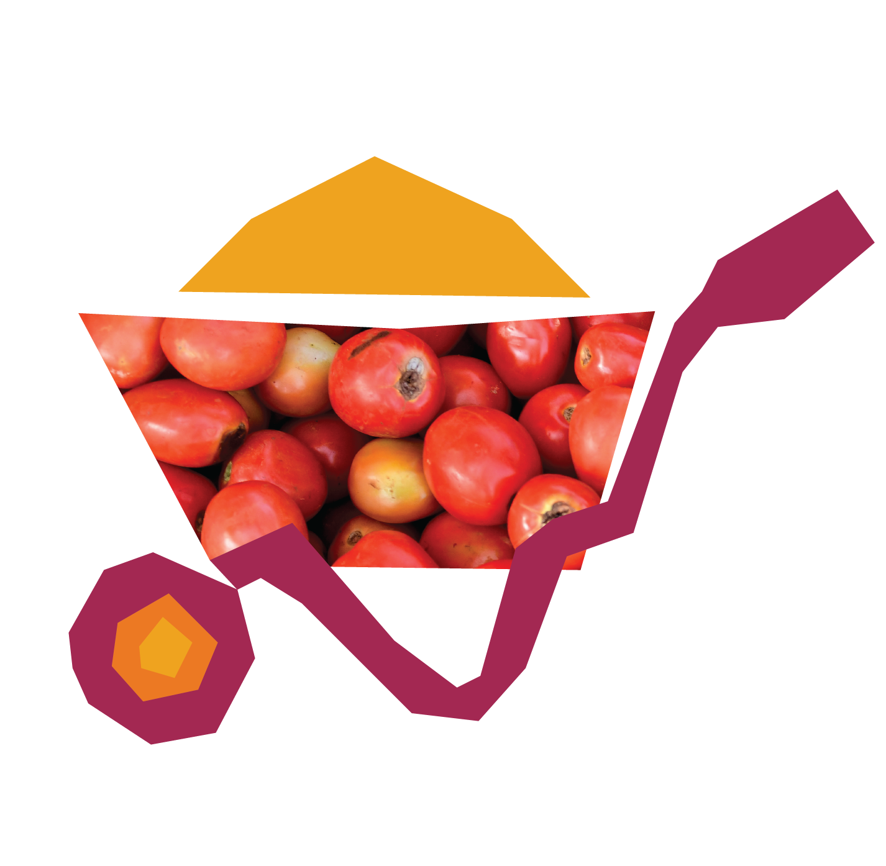
If appropriate, ask people to think about how they put hope into action. Then, as the last hymn is sung, invite them to come and write their ideas on plant name tags/markers and add to the garden.
Move your cone garden outside – maybe to the front of church so it can be enjoyed and used by the community.

Sing: When I needed a Neighbour
Words and music by Sydney Carter, with additional verses by Ally Barrett.

Christian Aid is a key member of ACT Alliance. Eng and Wales charity no. 1105851 Scot charity no. SC039150 Company no. 5171525
The Christian Aid name and logo are trademarks of Christian Aid. Printed exclusively on material sourced from responsibly managed forests.
©Christian Aid December 2025

