Christian Aid Week 2026
A guide to promoting Christian Aid Week in your community

Contents
Thanks for your support

- Thanks for your support
- Campaign article (around 1,000 words)
- Campaign article (around 700 words)
- Campaign article (around 300 words)
- 70k in May
- Christian Aid logos
- Images
- A guide to using our template press releases
- Template press release for general fundraising
- Template press release for 70k in May
- Editable Event poster
Hold your Ctrl key and click on the titles above to move directly to the relevant section of this document.



Thanks for your support

Thank you so much for promoting Christian Aid Week (10-16 May). We hope the stories and images in this pack will help you tell people about our work and encourage them to show their support too.

We each have seven days to make a difference and there are plenty of ways people can get involved.

In this pack, you’ll find Christian Aid logos for you to use, and an article about the campaign that’s the perfect length for websites and magazines. Plus, there are two shorter versions of the piece for newsletters and leaflets, along with images to accompany all three articles. We’ve shared some examples of what the donations we all raise this Christian Aid Week could go on to fund. You’ll also learn about our 70k in May fundraising challenge, which is a great opportunity to achieve some personal fitness goals while raising money.

If you’re using social media, don’t forget to tag us, so we can share your posts too!

• Facebook: @christianaid
• Twitter: @christian_aid
• Instagram: @christianaiduk

We have plenty of resources available for you to use at caweek.org/Resources and if you need extra support, please get in touch at hello@christian-aid.org.

Without your support, we couldn’t do all that we do – so thank you very much.

Campaign article (around 1,000 words)

Where hardship means hunger… urban farmers can grow hope.
In the crowded informal settlements of Nairobi, most parents wake with the crushing knowledge that if they don’t earn money that day, their children won’t eat that night.

That includes Fridah Moraa, a recently widowed grandmother who lives with her twin sons, daughter and grandson in Dagoretti, a sprawling settlement that’s among the biggest in Kenya.

‘When I wake up, I have a lot of worries. Sometimes I don't have food,’ says Fridah. The aching hunger is bad enough. The relentless stress is overwhelming. Fridah’s situation is devastatingly common.

That’s because alongside Nairobi’s imposing skyscrapers and luxury safaris, Kenya’s capital holds areas of acute deprivation.

In areas like Dagoretti, there are limited formal work opportunities and heartbreakingly low pay, with most people living on less than a dollar a day. On top of this, food prices are high, in part due to the climate crisis.

Most families spend a big proportion of their household income buying fresh vegetables and basic ingredients.

Getting three meals a day is not easy. Most manage two. Some, just one. Others go the whole day without eating. The terrible consequence of this situation is that many families are simply not getting the nutrition they need.

More than a third of Kenya’s population is undernourished. Almost a third of children in rural areas are stunted, and just over 4% of children die before their fifth birthday. The effects of malnutrition can last a lifetime, with stunting permanently affecting both physical and mental development.

Bad days
In the busy and noisy streets of Dagoretti, Fridah and her family live in rented corrugated metal shelters. They share toilet facilities with other families in the compound and have no running water. Day-to-day life is precarious and volatile. Fridah's worry about how to get enough food for everyone in her family resurfaces urgently every morning.

To bring in enough money to feed everyone, and cover all essential outgoings, Fridah sells vegetables on a market stall. She wakes early to carefully select the best produce at the wholesalers. With no means to keep her produce fresh, or space to store stock, Fridah makes the tiring two-hour round trip six times a week.

‘The challenge is that sometimes I have customers, but no money to buy vegetables. But I can't give up – my children need to go to school. They need to eat.’

On days when she doesn’t have enough customers, or cannot buy stock to sell, Fridah’s stress soars. At times like this, she’ll often go without food so that her children can eat a little.

‘Sometimes I don't know how I’ll buy food. I don't know how I’ll feed my family. But I believe in myself and pray to God that I will succeed.’

Growing hope
Thanks to an offer of support by Christian Aid’s partner, Beacon of Hope, Fridah’s now building her hope and resilience.

Fridah was introduced to an impactful agricultural project called ‘Imarisha Kilimo’ (which means ‘strengthen agriculture’ in Swahili), run by Beacon of Hope. This offers Dagoretti’s residents the opportunity to train as urban farmers.
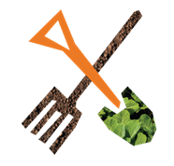
By offering skills training, seeds, tools and space-efficient plots to grow produce near their homes, parents like Fridah are turning the tide on urban poverty.

Central to this course of learning is how to tend cone gardens. These vertical planters, with tiers of produce, not only have a small footprint, but retain precious water. They don’t require ground to be dug and can be established in even Dagoretti’s narrowest alleyways. As Project Officer James Omwanda says: ‘There's not enough space. There's never enough space in Nairobi.’

Intrigued by the idea of growing food in the heart of the city, Fridah started attending urban farming training sessions. ‘At first, I didn't understand. I was wondering, where can someone farm here in Nairobi?’

With grit and determination, Fridah’s studying hard, making sense of all the lessons offered. Sessions don’t just cover farming techniques, such as pest management, compost production, and seed cultivation, but business skills, including money management and marketing.

Gaining both knowledge and confidence, Fridah was eager to start growing her own food. ‘I discovered I could sow here – right where I stand! I learned that here in Nairobi, you can farm where you live, even if you don't have land.’

Hidden at the end of a concrete alley, noisy with little children and dogs, and shaded by drying washing, you’d never guess a lush, plant-packed space could thrive.

As Fridah pulls open the rickety gate and takes in what she’s achieving, her face shines with pride. Ever resourceful, she’s using the metal fences for climbing plants and repurposing discarded containers as planters.

Fridah’s now beginning to reap the benefits of the nutritious produce she’s growing. Colourful kale, tomatoes and a range of indigenous vegetables are now being sold on her market stall and fed to her family.

Joyful Fridah delights in being able to nourish her family with the food she’s growing herself, which better protects them from the threat of malnutrition. From living meal to meal, not knowing if her children will go to bed with empty stomachs, she now cherishes the security her small urban farm is bringing. ‘Urban farming has changed my life.’

Fridah adds: ‘When what I have planted grows – that is what makes me happy. When I get money that I have earned – that is what makes me happy.’

Christian Aid and its supporters are joining together once again during Christian Aid Week (10-16 May) to fundraise in all kinds of ways – from coffee mornings and craft stalls to hiking and biking for the 70k in May challenge.

With seven days to make a difference, every gift, act and prayer counts. What will you do to support someone like Fridah to grow food, protect their children from hunger, and nurture hope?


- £5 could buy the seeds that kickstart a family’s nutritious vegetable garden.
- £10 could pay for the pair of chickens that produce fertiliser for an urban farmer.
- £15 could purchase the hand tools that mean an urban farmer can tend their crops.
- £30 could buy the trio of cone garden planters that host hundreds of plants in a tiny city space.
Find out more about the campaign at caweek.org

Campaign article (around 700 words)

Where hardship means hunger… urban farmers can grow hope.
In the crowded informal settlements of Nairobi, most parents wake with the crushing knowledge that if they don’t earn money that day, their children won’t eat that night.

That includes Fridah Moraa, a recently widowed grandmother who lives with her twin sons, daughter and grandson in Dagoretti, a sprawling settlement that’s among the biggest in Kenya.

‘When I wake up, I have a lot of worries. Sometimes I don't have food,’ says Fridah. The aching hunger is bad enough. The relentless stress is overwhelming. Fridah’s situation is devastatingly common.

That’s because alongside Nairobi’s imposing skyscrapers and luxury safaris, Kenya’s capital holds areas of acute deprivation.

In areas like Dagoretti, there are limited formal work opportunities and heartbreakingly low pay, with most people living on less than a dollar a day. On top of this, food prices are high, in part due to the climate crisis.

Getting three meals a day is not easy. Most manage two. Some, just one. Others go the whole day without eating.

The terrible consequence of this situation is that many families are simply not getting the nutrition they need, including children. The effects of malnutrition can last a lifetime, with stunting permanently affecting both physical and mental development.

Bad days
Like many others in Dagoretti, day-to-day life for Fridah is precarious and volatile. To bring in enough money to feed everyone, and cover all essential outgoings, Fridah sells vegetables on a market stall.

‘The challenge is that sometimes I have customers, but no money to buy vegetables. But I can't give up – my children need to go to school. They need to eat.’

On days when she doesn’t have enough customers, or cannot buy stock to sell, Fridah’s stress soars. At times like this, she’ll often go without food so that her children can eat a little.

‘Sometimes I don't know how I’ll buy food. I don't know how I’ll feed my family. But I believe in myself and pray to God that I will succeed.’

Growing hope and resilience
Fridah was introduced to an impactful agricultural project run by Christian Aid’s partner, Beacon of Hope. The project offers Dagoretti residents the opportunity to train as urban farmers. By offering skills training, seeds, tools and space-efficient plots to grow produce near their homes, parents like Fridah are turning the tide on urban poverty.

With grit and determination, Fridah’s studying hard. Sessions don’t just cover farming techniques, such as pest management, compost production, and seed cultivation, but business skills, including money management and marketing.

Gaining both knowledge and confidence, Fridah was eager to start growing her own food. ‘I discovered I could sow here – right where I stand! I learned that here in Nairobi, you can farm where you live, even if you don't have land.’

Hidden at the end of a concrete alley, you’d never guess a lush, plant-packed space could thrive. As Fridah pulls open the rickety gate and takes in what she’s achieving, her face shines with pride.

Fridah’s now beginning to reap the benefits of the nutritious produce she’s growing. Colourful kale, tomatoes and a range of indigenous vegetables are now being sold on her market stall and fed to her family.

From living meal to meal, not knowing if her children will go to bed with empty stomachs, Fridah now cherishes the security her small urban farm is bringing, knowing that she can better protect her children from the threat of malnutrition. ‘Urban farming has changed my life.’

Fridah adds: ‘When what I have planted grows – that is what makes me happy. When I get money that I have earned – that is what makes me happy.’

Christian Aid and its supporters are joining together once again during Christian Aid Week (10-16 May) to fundraise in all kinds of ways – from coffee mornings and craft stalls to hiking and biking for the 70k in May challenge.

With seven days to make a difference, every gift, act and prayer counts. What will you do to support someone like Fridah to grow food, protect their children from hunger, and nurture hope?

· £5 could buy the seeds that kickstart a family’s nutritious vegetable garden.
· £10 could pay for the pair of chickens that produce fertiliser for an urban farmer.
· £15 could purchase the hand tools that mean an urban farmer can tend their crops.
· £30 could buy the trio of cone garden planters that host hundreds of plants in a tiny city space.

Find out more about the campaign at caweek.org

Campaign article (around 300 words)

Where hardship means hunger… urban farmers can grow hope.

In the crowded and noisy settlements of Nairobi, most parents wake every single day knowing that they must go and earn money, otherwise their children won’t eat that evening.

With no formal work opportunities, heartbreakingly low pay, and no social support, it’s a precarious and frightening daily struggle that no family should have to face.

The aching hunger is bad enough. The relentless stress is overwhelming. ‘When I wake up, I have a lot of worries. Sometimes I don't have food,’ says Fridah Moraa, a recently widowed grandmother determined to support her family on what little she earns.

‘Now I'm responsible for everything.’ With school costs, rent and water to cover, providing food for every meal is a problem that never goes away.
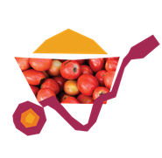
But Fridah’s faith in God, and in her own ability to provide, is unwavering. With tools, seeds and specialist training from Christian Aid’s partner, Beacon of Hope, Fridah’s now making the most of a small space in the city to grow a steady supply of fresh vegetables that she can cook for her family or sell on her market stall.

Reflecting on her new role in life, Fridah says: 'I never thought that a woman could also be a provider.’

With her inner strength, unstoppable resolve, and a little help from Beacon of Hope, Fridah’s overcoming poverty to feed the youngest members of her family and protect them from the threat of malnutrition.

Fridah rightly takes pride in all she’s achieving: ‘When I harvest what I’ve planted, it makes me happy. Urban farming has changed my life.’

Christian Aid and its supporters are joining together once again during Christian Aid Week (10-16 May) to fundraise in all kinds of ways – from coffee mornings and craft stalls to hiking and biking for the 70k in May challenge.

With seven days to make a difference, every gift, act and prayer counts. What will you do to support someone like Fridah to grow food, protect their children from hunger, and nurture hope?

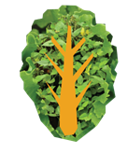
· £5 could buy the seeds that kickstart a family’s nutritious vegetable garden.
· £10 could pay for the pair of chickens that produce fertiliser for an urban farmer.
· £15 could purchase the hand tools that mean an urban farmer can tend their crops.
· £30 could buy the trio of cone garden planters that host hundreds of plants in a tiny city space.

Find out more about the campaign at caweek.org

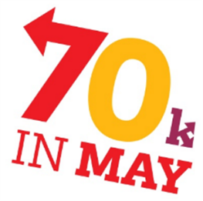
70k in May

This year’s Christian Aid Week is focused on Nairobi, Kenya, where families are working hard to beat urban poverty and hunger.

Meanwhile, Christian Aid’s supporters are showing solidarity with their global neighbours by signing up for the annual 70k in May fundraising challenge.

You can cover the 70km distance any way you like. You could take part by yourself or form a group with your church, friends or family. You can split it into manageable sections or even do it in relay. However you take on 70k in May, do it your way!

If you’re on social media, you could post your challenge and inspire others. You can even bag yourself a welcome pack with a t-shirt when your fundraising hits £10!

To help you promote your challenge in your local community, we’ve created a template press release for you. You’ll find it in this pack, ready to be tailored for your event or activity. Simply fill in the details relevant to your group, add your story, and share it with your local media to help spread the word and inspire others to get involved.
Find out more and how you can take part at christianaid.org.uk/70kinmay

70k in May logos
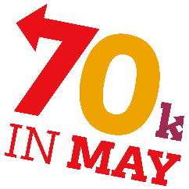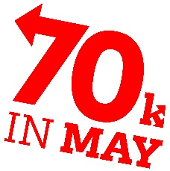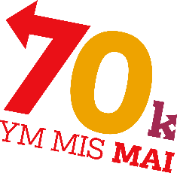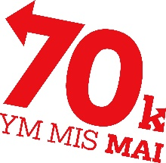
Please apply the most relevant logo in a top-left corner.
Christian Aid ‘In aid of’ logos

When organising a fundraising event, volunteers have an important responsibility to uphold the charity’s reputation and values. When promoting such events, the ‘in aid of' logo should be used, signifying an independent fundraising effort that is not directly managed by the charity.

It is essential that volunteers use the logo accurately and respectfully, ensuring it is not misrepresented as an official endorsement or direct action by the charity.

For full guidelines please visit caweek.org/Logo

When using this logo, volunteers must follow any provided guidelines, avoid altering the logo, and use it only for approved activities that genuinely support Christian Aid’s mission.

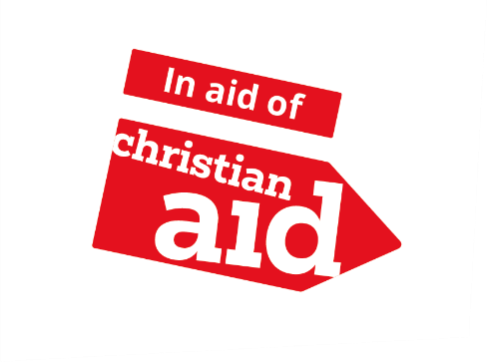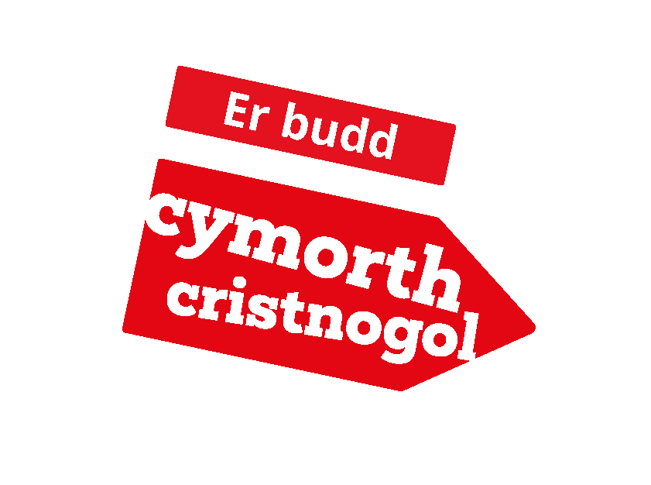
Please apply the most relevant logo in a top-left corner.

Images

When using images, please ensure the full caption and credit is included:
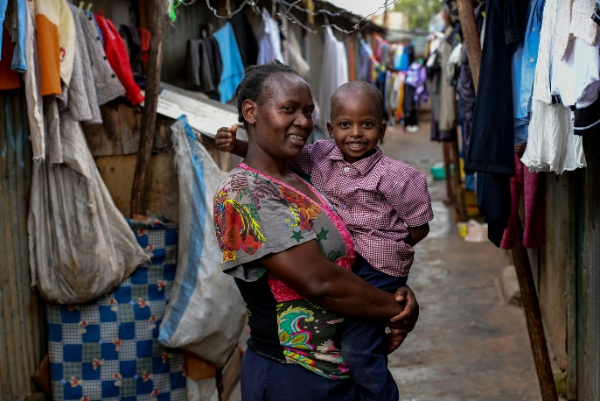 | 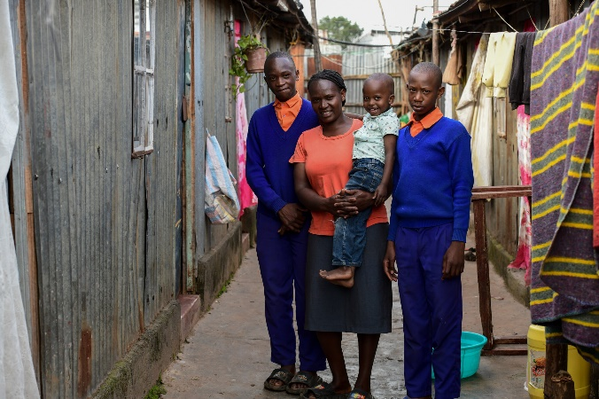
Caption: Fridah with her grandson, Quillan, outside their house in Dagoretti, Nairobi.  Credit: David Macharia/Christian Aid | Caption: L-R: Abiud, Fridah, Quillan and Eliud outside their home in Dagoretti, Nairobi.  Credit: David Macharia/Christian Aid
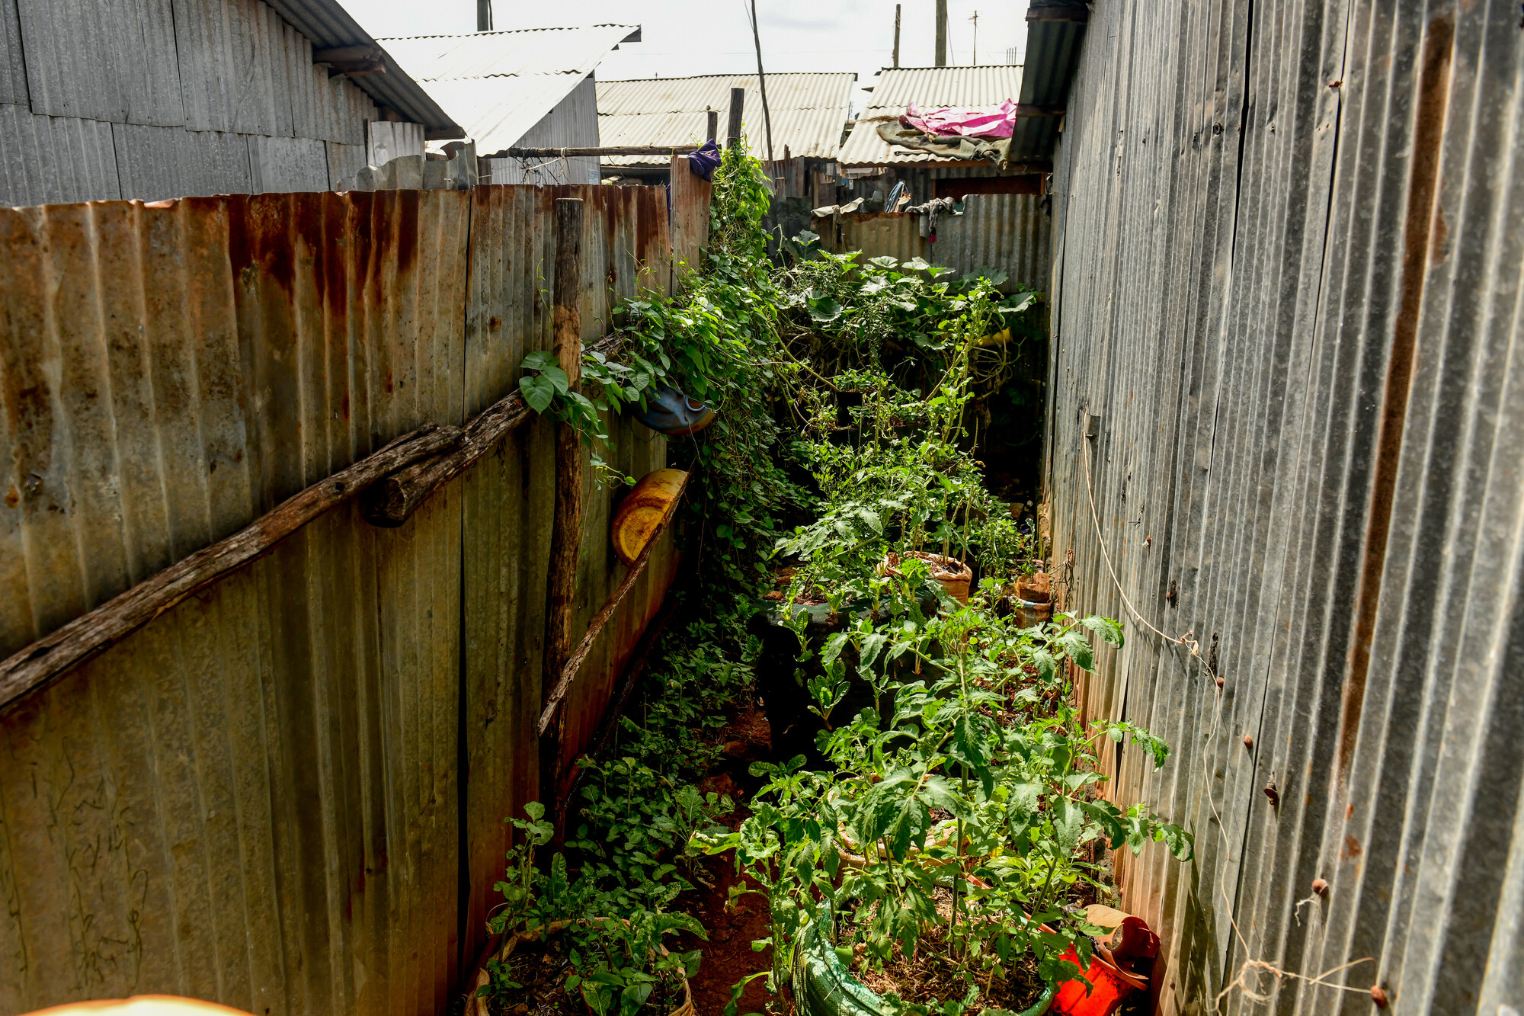 | 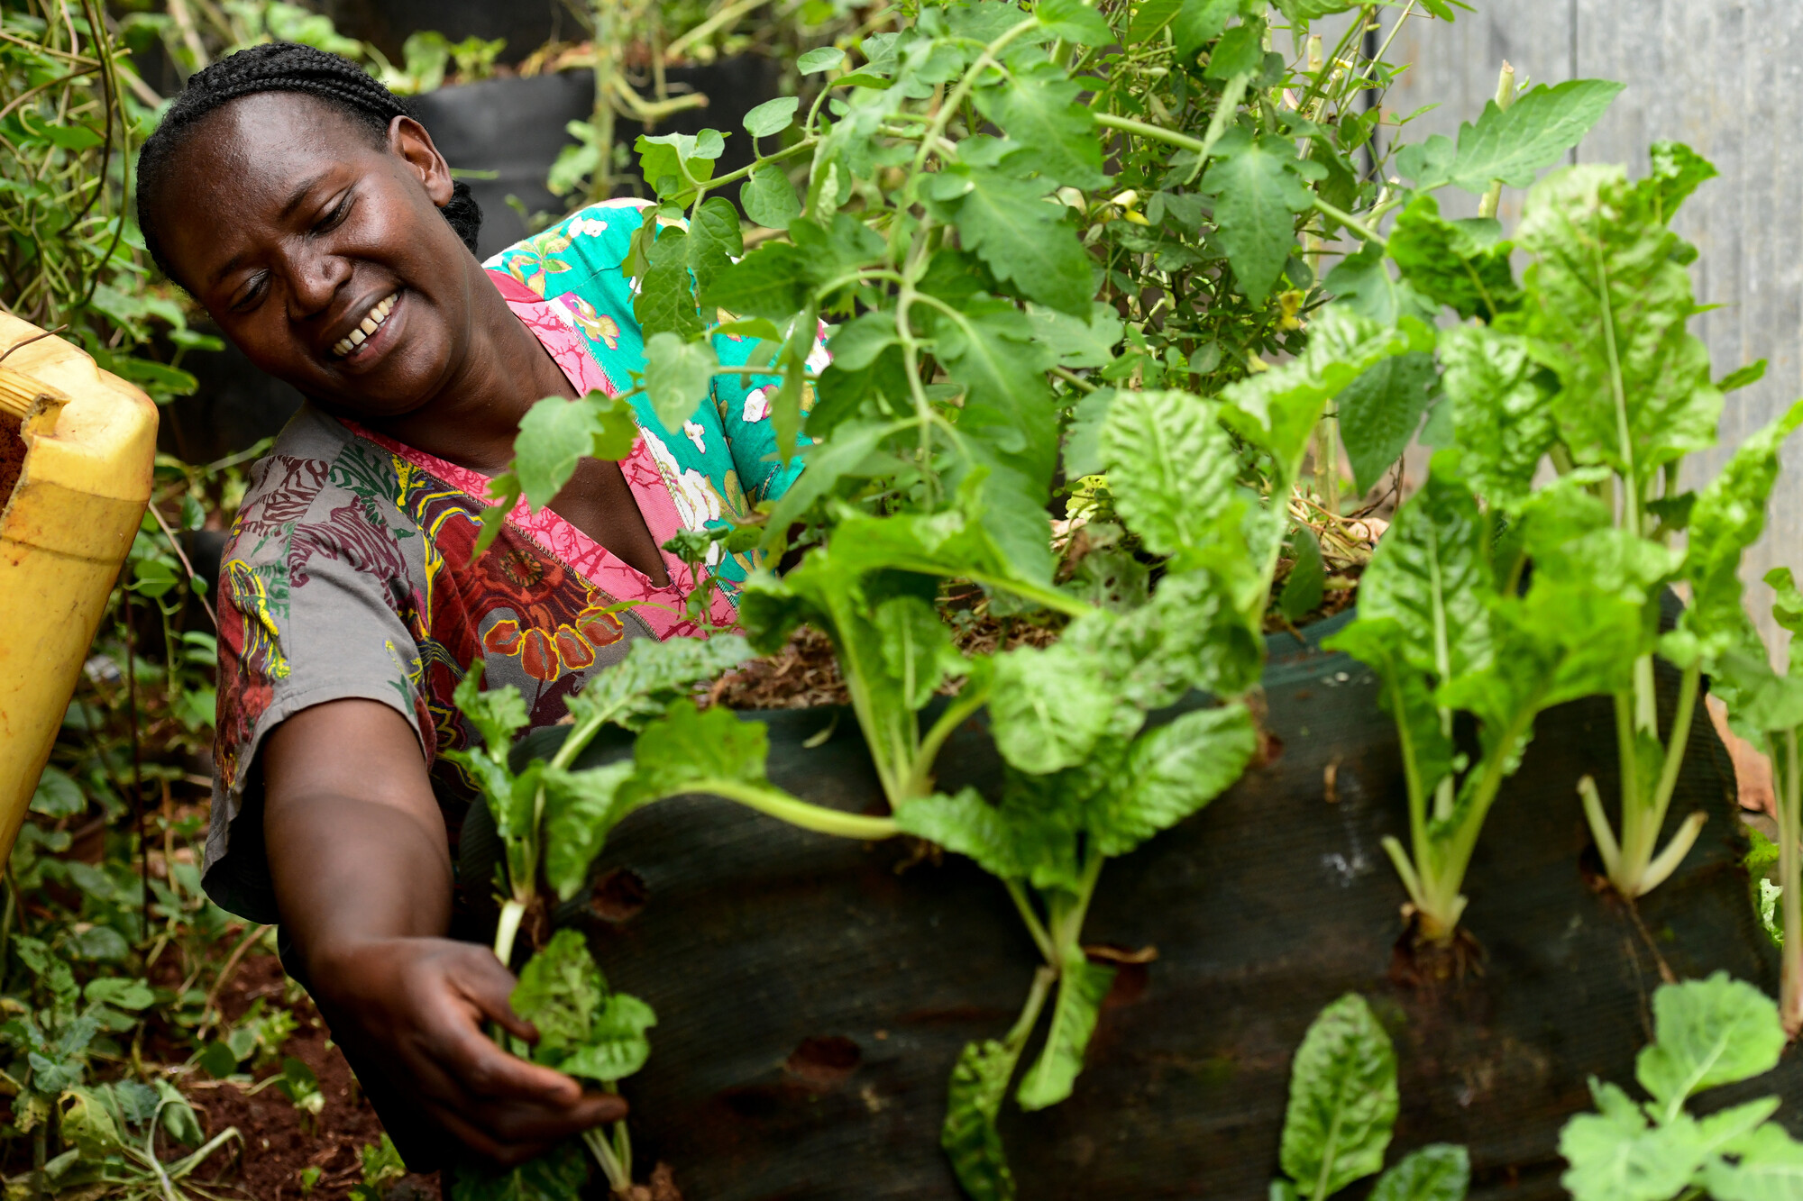
Caption: Fridah’s turned a tiny unused space into a source of nutrition and income for her family.  Credit: David Macharia/Christian Aid | Caption: Fridah tends her small city plot, tucked away at the end of an alley by her home in Dagoretti.  Credit: David Macharia/Christian Aid

A guide to using our template press releases
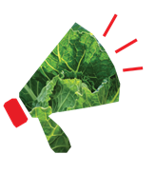
Thank you for supporting Christian Aid, and for sharing what you’re doing with your local press. Our template press releases are designed to give you a foundation for getting your message out to newspapers, radio and television in your community, and further afield.

Here’s the best way to use these press releases:

- Copy and paste the whole release into a new document so you have the original for a follow-up story (about how much you raised, for example).
- Fill in the parts in red (change the colour back to black and un-bold) – adding/deleting/changing quotes to your own words, as appropriate.
- Attach a photo that illustrates your story (one which has people in it preferably – with first and second names if there are fewer than five people).
- You can then send the release and photo/s out to the media yourself (the emails of news desks can be found on the relevant media’s website), or you can email Juliet Lunam at JLunam@christian-aid.org who will be happy to send it out for you to all relevant outlets, and organise any interviews that may be requested.

Template press release for general fundraising

NEWS RELEASE
[INSERT TOWN] fundraisers gear up for major charity appeal to support communities living in poverty.
[INSERT NAME OF GROUP eg Salisbury Christian Aid Group] has organised [INSERT ACTIVITY eg a sponsored cycle, a coffee morning] as part of Christian Aid Week 2026.
Organiser/Christian Aid Group chairperson [DELETE/AMEND AS APPROPRIATE AND INSERT NAME eg Jane Smith] said: ‘Every year, during this appeal, people across Britain and Ireland have seven days to make a difference and raise funds for Christian Aid Week. We hope people will get behind our fundraising and support their global neighbours.
“We’re taking part by [INSERT WHAT, WHERE, DATE AND TIME] because [EXPLAIN WHY THIS IS IMPORTANT TO YOU.]”
Money raised will help Christian Aid and its partners to support communities to find practical and sustainable ways out of poverty.
This year’s appeal, which runs from May 10-16, is focusing on work in Nairobi, Kenya, where intense poverty means families have a daily struggle to feed their children.
With secure jobs hard to find, and most people earning less than a dollar a day, to cover school costs, rent and water, providing food for every meal is a relentless problem.
But with tools, seeds and specialist training from Christian Aid’s partner, Beacon of Hope, families are learning how to make the most of a small space in the city to grow a steady supply of fresh vegetables to cook or sell.

To find out more about projects like this, visit caid.org.uk
To get involved with Christian Aid Week, visit caweek.org
ENDS

Notes to editors:
To find out more about Christian Aid Week, the events and challenges taking place, and the people whose stories we’re sharing, visit caweek.org
For more information, contact Juliet Lunam, Media Advisor: JLunam@christian-aid.org

Template press release for 70k in May

NEWS RELEASE
[INSERT TOWN, ROLE AND NAME eg Halifax former teacher John Smith/Bristol vicar the Rev Jane Smith] is going the extra mile to support communities living in poverty.
The [INSERT AGE]-year-old [OR JUST PUT FIRST NAME] is taking part in the 70k in May challenge for Christian Aid Week 2026.
The idea is to cover 70km in any way you choose to raise money for the work of Christian Aid’s partners around the world.

[INSERT FIRST NAME] said: “Every year, during this appeal, people across Britain and Ireland have seven days to make a difference and raise funds for Christian Aid Week. We hope people will get behind our fundraising and support their global neighbours.
“I’m doing the 70k in May challenge because [EXPLAIN WHY THIS IS IMPORTANT TO YOU]. The plan is to [EXPLAIN HOW YOU’LL BE COVERING THE 70K].”
Money raised will help Christian Aid’s partners to support communities to find practical and sustainable ways out of poverty.
This year’s appeal, which runs from May 10-16, is focusing on work in Nairobi, Kenya, where intense poverty means families have a daily struggle to feed their children.
With secure jobs hard to find, and most people earning less than a dollar a day, to cover school costs, rent and water, providing food for every meal is a relentless problem.

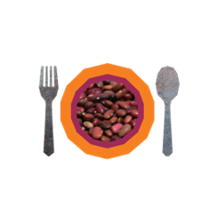
But with tools, seeds and specialist training from Christian Aid’s partner, Beacon of Hope, families are learning how to make the most of a small space in the city to grow a steady supply of fresh vegetables to cook or sell.

To find out more about projects like this, visit caid.org.uk
To get involved with Christian Aid Week, visit caweek.org

ENDS

Notes to editors:
To find out more about Christian Aid Week, the events and challenges taking place, and the people whose stories we’re sharing, visit caweek.org
For more information, contact Juliet Lunam, Media Advisor: JLunam@christian-aid.org

Editable Event Posters
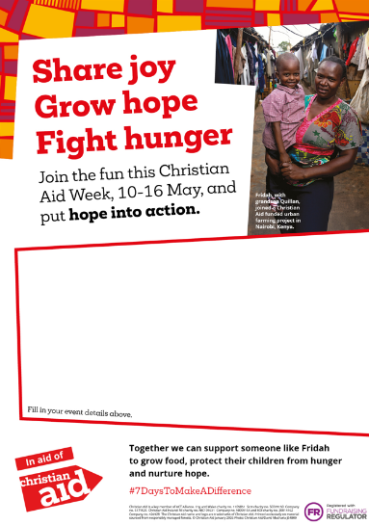
If you would like to create a poster to promote your fundraising event for Christian Aid Week, please visit caweek.org/resources to download an editable version of the poster below. Both English and Welsh bilingual versions are available.
When customising your poster, remember to include:
- The date and time of your event
- The location
- A brief description of the event
- Contact details for further information or to get involved
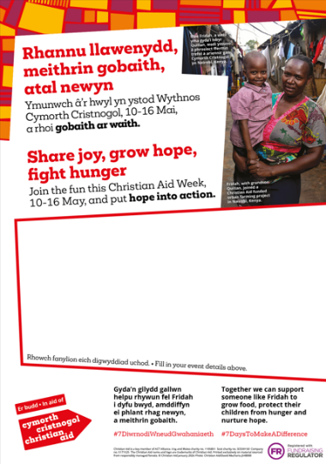
Providing these details will make it easier for people to join and support your fundraising efforts.

Thank you for your support this Christian Aid Week.

Christian Aid is a key member of ACT Alliance. Eng and Wales charity no. 1105851 Scot charity no. SC039150 Company no. 5171525
The Christian Aid name and logo are trademarks of Christian Aid.

